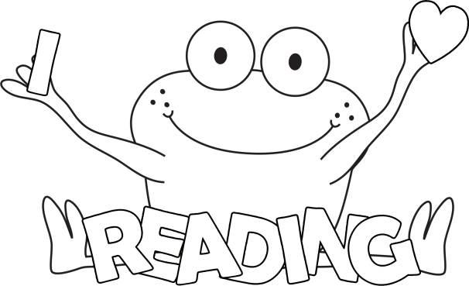 September 2014
Dear Kingsley Families,
We are off to another great school year and have already started our at home reading program. Our Home Connection Reading program is called “Let’s Read Together!” The “Let’s Read Together” log will come home each Friday to log minutes read. The log will be returned the next Friday. The reading log is the reading homework for our students. Throughout the year, we draw names from the returned logs and give away books for your home libraries.
Grade level expectations for the minutes read are listed on the bottom of the log.
- K-1 (50 minutes a week)
- 2-3 (100 minutes a week)
- 4-5 (150 minutes a week)
What counts as reading minutes?
- Any minutes students read outside of school
- Reading with a parent or sibling
- Reading alone
- Reading the pictures (younger students)
What kind of reading counts?
- Books from the library or school
- Books from home
- Newspaper, brochures, any real –life text
- A story written by your student
- Books on the computer, informational websites
We appreciate any reading practice completed at home. The best way to strengthen and maintain our reading skills is to practice.
Happy Reading!
Holly Ritter, Literacy Coach
Kim Brimm, Reading Interventionist

